Concise status of the birds of
Cheshire Wildlife Trust’s
Gowy Meadows Reserve

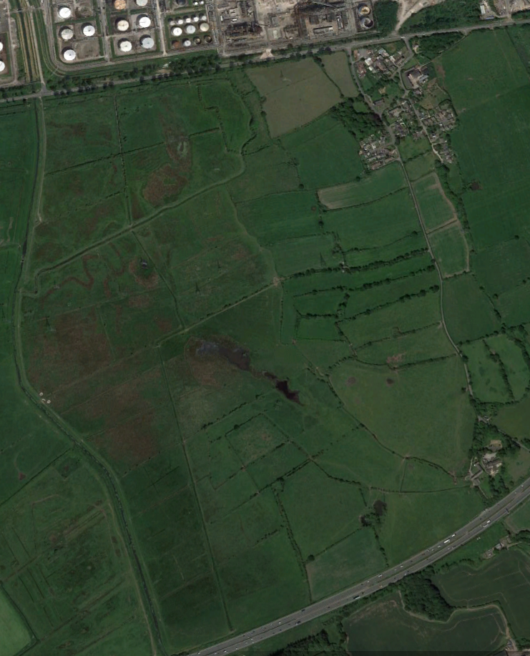
Up to mid-August 2017 the species listed below have all been recorded on the Trust’s reserve at Gowy Meadows, adjacent to Thornton-le-Moors. It has been prepared to give an indication as to what opportunities there are regarding bird species possible to see if the reserve is visited by the casual observer. With one or two exceptions, information used to base species’ assessments on has been accrued over the period March 2004 to August 2017.

Pink-footed Goose: Hard weather movements of birds from traditional wintering sites (such as the south Lancashire mosses) are undoubtedly the cause of the nine records accrued since 2006. Only ever recorded between December and February.

Greylag Goose: Annual visitor in very small numbers that has bred on occasion. No records from any of July, December or January.

Canada Goose: Similar to Greylag above, though there are no records for July. The peak count is 73. Has bred.

Mute Swan: Though uncommon enough to not be expected to be seen every time, small numbers of up to eight have been recorded in every month of the year. Has bred.

Common Shelduck: Despite large numbers being present on nearby estuaries, this species is nothing other than a vagrant, with just nine records between April and June; not seen since 2014.

Mandarin Duck: Very uncommon visitor though thought to have bred on occasion. The 15 records span February to June and August.

Gadwall: As with most wildfowl species Gadwall can be expected in small numbers (up to 14) at any time of year apart from June and July. However, presence is totally reliant on enough water being present in the ephemeral ‘ponds’ on the reserve as they are practically unknown on the Gowy itself. First recorded in 2012 and probably one of the few species marginally increasing.

Eurasian Wigeon: Odd birds can be found from September onwards and if conditions are right numbers will increase throughout the winter until the last birds move away in April. Peak count is of 266, though 60-80 is more normal.

Mallard: Year-round resident in small numbers and breeds. Numbers are swollen in winter under favourable conditions, when up to 450 have been recorded.

Northern Shoveler: Much like Gadwall, though has bred once. Recorded in every month apart from July with a peak of 73.

Northern Pintail: Vagrant, with all three records coming from 2013, when seen in March, April and November.

Garganey: Annual since first recorded in 2012 (though no records to date for 2017) with records from both passage periods (March to May and August to September). Up to three birds have been seen and a pair spent a month on the reserve in 2015 and may have bred but for the disappearance through evapouration of the pond they were ‘resident’ on during that time.

Common Teal: The commonest duck, with records from every month and in every year. Doesn’t breed despite a few individuals lingering long into April most years. Three-figure counts are regular under the right conditions with a peak of 400.

Tufted Duck: Uncommon to rare visitor annual since 2009 though with no December records. Has bred. Peak count of 11.

Goosander: Vagrant. One record from March 2011.
Red-legged Partridge: Vagrant: One record from June 2008. The possibility of this having been a ‘put down’ individual from west of the river cannot be discounted however.

Grey Partridge: Vagrant: Four records, the last in 2015. ‘Put down’ birds cannot be ruled out for this species either though 10 were seen together in October 2011.

Common Pheasant: Annual since first recorded in 2011 but invariably heard rather than seen. Has bred.

Little Grebe: Very uncommon resident – and then only when conditions are favourable enough to attempt breeding. Seen in every month, though winter records are almost exclusively on the Gowy rather than the ponds actually on the reserve. Peak count is of 10 but the norm is one to three.

Great Cormorant: Regular visitor in very small numbers and invariably seen flying over. Perhaps increasing with up to five being recorded roosting in trees together since 2015.

Grey Heron: Can be reasonably be expected on any visit as birds have been recorded in every month and in every year. Two-three is the norm but there has been up to six.

Great Egret: Vagrant: One record of two birds together in January 2013.

Little Egret: Generally a winter visitor (December to March) in very small numbers, typically one but up to five have been seen together.

Glossy Ibis: Vagrant: A bird spent periods of time on the reserve over February to April 2006.

Osprey: Vagrant: single birds on passage in April 2015 and 2016.

European Honey Buzzard: Vagrant: Single birds in September 2015 and June 2016.

Eurasian Marsh Harrier: Very uncommon but marginally increasing visitor with records during both passage periods (April to June and September to November). Up to two have been seen together but no male ever seen. One has been observed chasing a flushed Woodcock!

Northern Harrier: Vagrant: two records only, the last being of two together in April 2013.

Eurasian Sparrowhawk: Though recorded in every month and in almost every year Sparrowhawk is an irregular visitor to the reserve. Four in early October 2011 may have been birds on passage as the norm is just one.

Northern Goshawk: Vagrant: singles in February 2011 and September 2013.

Red Kite: Vagrant: the only record concerned two together on 22nd July 2017.

Rough-legged Buzzard: Vagrant: One spent an hour hunting over the reserve on 25th October 2014.

Common Buzzard: Resident in small numbers with records in all months and from every year. Has bred. Up to 18 have been seen a day.

Water Rail: Vagrant though has bred once. Recorded in November 2011 and three times during 2014, when up to two juveniles present. Not seen since.

Common Moorhen: Year-round resident in small numbers. Has bred. Up to 30 have been seen in winter.

Common Coot: Year-round resident when conditions allow. Has bred. Up to 29 have been seen in winter.

Eurasian Oystercatcher: Irregular visitor (by no means annual) and generally flying over. Recorded between February to August and November, with a maximum of two.

European Golden Plover: Vagrant: One record (of two) in March 2013. Strangely rare given the numbers of Lapwing that can be present, whose flocks seem incapable of pulling in more birds.

Northern Lapwing: Year-round resident that has bred. Recent evidence suggests it to be declining, both as a winter visitor and a breeder (rarely breeds on the reserve but present in close vicinity). The peak counts in winter can produce up to 1500 birds though flocks of 2-500 are more likely.

Little Ringed Plover: Vagrant: Discounting possible duplication, seven records between April and June over 2013-2017. Generally one but once a presumed pair.

Common Sandpiper: Vagrant: Very much water dependant. Up to three birds have been seen in April, June and July.

Green Sandpiper: Regular visitor though predominantly during winter. More than three times commoner than the previous species; up to four have been seen together.

Spotted Redshank: Vagrant: One record in September 2012.

Common Greenshank: Vagrant: Two records, from March 2012 and May 2017.

Wood Sandpiper: Vagrant: One record, from August 2013.

Common Redshank: Irregular visitor with records missing from July, September and October. Very much reliant on harsh weather including frosts and snow. Just 13 records, but annual since 2013.

Whimbrel: Vagrant with just eight records of up to two birds in March to May, July and September. Not seen since 2013.

Eurasian Curlew: Surprisingly rare with records far from annual and predominantly during winter. As with Redshank, needs to have been driven here by harsh conditions elsewhere despite wintering grounds for up to 200 being no more than three kilometres away. Maximum of just two.

Black-tailed Godwit: Vagrant: Most of the 10 records probably relate to a flock of up to 55 birds that spent some time on the reserve in April 2015. The only other record concerned one in November 2014.

Dunlin: Vagrant: One in April 2014 is the only record.

Jack Snipe: Rare to regular winter visitor, with records from all months between September and April. Extremely difficult to see due both to the species habit of being practically invisible and their presence invariably being away from public access. Birds flushed by either dogs or the occasional presence of wildfowlers have been seen several times.

Common Snipe: Hugely more common than the previous species and though birds are more commonly seen flying around, preferred habitats being away from public access means it can be just as difficult to see. Recorded every year in all months except June, the peak is 260; however, any accurate counting is hampered by the size of the reserve.

Eurasian Woodcock: Almost annual since first recorded in 2010, but absolutely reliant on harsh weather. Under such conditions, they can be found just about anywhere though just 10 records confirms them to be a Vagrant.

Black-headed Gull: Apart from the distinctly uncommon Common Gull, the remaining four ‘usual suspect’ gull species are probably all under-recorded including the current species. That having been said, and despite gulls in their thousands passing over between the Mersey estuary and Gowy landfill site, seeing any actually on the ground is a notable event. Numerically speaking Black-headed Gull is the second commonest species and up to 3000 have been seen in a day.

Mediterranean Gull: Vagrant: Four records of four individuals in April, September and December. Not seen since 2013.

Common Gull: Though seen in all months October to May this is practically a rarity on the reserve with just 23 sightings in total since 2005. It’s not quite annual, going unrecorded in both 2006 and 2010. Early spring is the best time to see them as they head north on passage, when up to 50 have been seen.

Herring Gull: Commonest gull by far, almost as common as the remainder combined. Four-figure counts of birds passing over are not uncommon, with a peak of 3500 in September 2015 illustrating the point.

Yellow-legged Gull: Vagrant: Three records of six individuals in February 2011 and (four) March 2013. Not seen since.

Lesser Black-backed Gull: Only slightly more common than Common Gull, this is a spring migrant in particular with odd wintering records from time to time. April is the month of spring passage, when up to 500 immaculate adults have been seen passing through.

Great Black-backed Gull: Present year round though number are never large. Peak count of 350 came from April 2017.

Sandwich Tern: Vagrant: One record, from March 2017.

Stock Dove: Year-round resident that has bred. Not generally prone to forming large flocks, the peak count is nonetheless 80. Only not recorded in June and seen every year.

Common Wood Pigeon: Under-recorded year-round resident that breeds. Three-figure count are not unusual in winter, with a peak of 450.

European Turtle Dove: Vagrant: One record from May 2014.

Eurasian Collared Dove: Vagrant, though possibly under-recorded. Odd birds seen flying through don’t always get into the notebooks, thus perpetuating the likely myth.

Common Cuckoo: Vagrant: Despite the habitat being everything a cuckoo might need (with breeding Meadow Pipits and Reed Warblers for example) it’s barely annual since first recorded in 2009, going unseen in both 2011 and 2014. All records are from April to June.

Barn Owl: Vagrant: Has bred. Seen most years by a lucky few.

Little Owl: Vagrant: Very few records from 2013, 2016 and 2017. Has bred.

Tawny Owl: Vagrant: One record from November 2011.

Short-eared Owl: Vagrant, mainly winter visitor whose presence is also weather dependant. Up to five have been seen together though the norm is just one. If hunting, has been seen to be mobbed by over 20 Magpies!

Common Swift: Yearly visitor in small numbers between April and September with a peak of 31 in May 2017.

Common Kingfisher: Very rare late autumn to spring visitor, annual since 2011. Possible on any stretch of water though it does favour the River Gowy.

Eurasian Wryneck: Vagrant: One record from October 2011.

Great Spotted Woodpecker: Year-round resident which may have bred. Only absent over 2005-06 for reasons not obvious. Up to three have been seen or heard in a day.

Common Kestrel: Year-round resident that has bred. Numbers swell in winter, when up to 10 have been seen in a single day.

Merlin: Very rare visitor between August and January. Probably declining despite 2013-14 (and thus far in 2017) being the only years has gone unrecorded.

Eurasian Hobby: Very rare visitor, predominantly in spring and autumn passage when up to three together have been recorded.

Peregrine Falcon: Remains unrecorded in July despite the probability that a pair breeds most if not every year within the confines of the Essar refinery. Birds can be seen hunting over the reserve when species as wide ranging from Teal to Starling have been their quarry.

Eurasian Jay: Year-round resident in very small numbers that has bred. Numbers swell during winter, when a peak of six has been recorded.

Eurasian Magpie: Very common year-round resident that breeds. Up to 25 have been seen together.

Eurasian Jackdaw: With no records in June or July, data suggests it’s a non-breeding species that in all probability also goes under-recorded. Up to 50 have been seen together.

Rook: With just four records the tag of Vagrant is certainly deserved for a species which can winter in its hundreds just three kilometres away. Thirty in January 2006 is the peak count.

Carrion Crow: Under-recorded year-round resident that has bred. Peak count is of 75.

Common Raven: Year-round resident that has bred but which traditionally does so within the refinery complex to the north of the reserve. Recorded every year with a peak of nine.

Sky Lark: Year round resident that has bred. When obliged to by poor weather, generally moves away in winter, returning in March up to 75 have been seen in a day.

Wood Lark: Vagrant: One record, from June 2009.

Sand Martin: Surprisingly uncommon, with no records in 2011or 2016 since first recorded in 2010. Fifty together in late August 2014 represented almost half the individuals ever recorded. Sometimes seen in flocks of the next species during passage.

Barn Swallow: Annual summer visitor between April and October. Can be very common on autumn passage, when up to 1015 have been recorded in late September.

Common House Martin: Uncommon annual summer visitor between April and September. Commoner in autumn, when up to 234 have been seen in a single day,

Marsh Tit: Vagrant: One record, from November 2004.

Coal Tit: Vagrant: Not recorded since 2012.
Great Tit: Common year-round resident that has bred. Numbers in winter flocks can reach 25.

Eurasian Blue Tit: Common year-round resident that has bred. Numbers in winter flocks can reach 15.

Long-tailed Tit: Uncommon year round resident whose number fluctuate depending on winter temperatures and conditions. Up to 40 have been seen together.

Eurasian Nuthatch: Vagrant that has possibly bred. First recorded in 2006 but nothing like annual.

Eurasian Treecreeper: Vagrant: Exclusively winter visitor with only three records, the last in 2015.

Eurasian Wren: Very common, year-round resident that has bred. On breeding survey transects, up to 10 have been seen in a day.

Goldcrest: Distinctly uncommon. Records only annual since 2012, with a maximum of three in any one day.

Willow Warbler: Formerly (pre-2008) much commoner than to-day when it bred regularly. Predominantly a bird of spring passage now, when up to six have been seen. Smaller autumn passage.

Common Chiffchaff: In terms of both sightings and number of individuals, by far the commonest warbler species with records from ever month other than February. Wintering is nonetheless rare. Up to 15 have been seen or heard in a single spring day.

Sedge Warbler: Spring migrant in small numbers. Has bred.

Eurasian Reed Warbler: Spring migrant in very small numbers: Has bred.

Common Grasshopper Warbler: Rare spring migrant in very small numbers. More likely to be heard than seen. Last recorded in 2014.

Blackcap: Fairly common spring migrant that has bred. Very rare in winter.

Garden Warbler: Practically a vagrant, but probably a very rare spring migrant; not annual.

Lesser Whitethroat: Uncommon spring migrant: annual since first recorded in 2009. Two or three in a day would be a good record.

Common Whitethroat: Fairly common spring migrant that has bred.

Spotted Flycatcher: Vagrant: One record in May 2016.

European Robin: Common year-round resident.

Common Redstart: Vagrant. Five records from April, May and August.

Black Redstart: Vagrant: one record from May 2012.

Whinchat: Uncommon spring (April to May) and rare autumn (August, September and October) migrant. Up to seven birds have been seen in a day in either season.

European Stonechat: Uncommon year-round resident with short duration early spring passage. Population affected by harsh weather and in such conditions can be completely absent for months on end. Spring passage can be spectacular, with 47 birds present in 2015.

Northern Wheatear: Uncommon to common spring (March to June) and rare autumn (August to October) passage migrant. Up to 65 have been seen in a single day in spring.

Ring Ouzel: Vagrant: two records in April of 2012 and 2016.

Eurasian Blackbird: Common year-round resident. Up to 20 have been recorded in a single day.

Fieldfare: Common to uncommon winter resident (October to April). Up to 800 have been seen in a single day.

Redwing: Common to uncommon winter resident (October to April). Up to 750 have been seen in a single day.

Song Thrush: Surprisingly perhaps, un-recorded in July-August though seen every year. Uncommon Year-round resident that has bred. Peak of 10 but generally 4-6 in a day.

Mistle Thrush: Rare year-round resident that has bred. Peak is five in a day.

Common Starling: Uncommon to very common (winter) year-round visitor that has bred. Peak of 2000 in November 2010.

Dunnock: Uncommon year-round resident. Under-recorded.

Grey Wagtail: Rare visitor: Most records in winter but once seven on an autumn migration watch.

White Wagtail: Vagrant: Two records from April 2013 concerned five birds. Pied Wagtail is an uncommon year-round resident in small numbers; up to 15 have been seen in a day.

Meadow Pipit: Uncommon year-round resident that can pass through in large numbers during autumn passage (519 on 1st October 2011, 271 on 27th September 2014).

Tree Pipit: Vagrant: one record from 26th August 2012.

Yellowhammer: Formerly commoner but now a vagrant: Three birds present on 1st Jan 2006 was the last record.

Reed Bunting: Uncommon year-round resident that has bred. Up to 40 seen during autumn and 65 in winter.

Common Chaffinch: Common year-round resident whose numbers can swell to up to 310 in winter.

Brambling: Vagrant: Four records only, the last three of which all came from winter 2010 when seven birds seen in total.

Eurasian Bullfinch: Rare year-round resident, annual since first recorded in 2007. Rarely more than two on any given day.

European Greenfinch: Surprisingly uncommon year-round resident with a peak day count of just five.

Lesser Redpoll: Vagrant: Two records of singles in 2016, in May and November.

Eurasian Siskin: Vagrant: One record of three in October 2013.

European Goldfinch: Predominantly winter visitor though has bred in very small numbers. Flocks can be seen in autumn and winter, when numbers up to 240 have been recorded.

Twite: Vagrant: One amongst Linnets in March 2013 is the only record.

Common Linnet: Uncommon year-round resident whose numbers swell in winter; up to 250 have been recorded.

House Sparrow: Despite a flourishing population in Thornton-le-Moors, this species is practically a vagrant to the reserve with very few records. Probably bred in 2017, perhaps for the first time and away from human habitation.

Eurasian Tree Sparrow: Vagrant: two records only, the last in 2017.

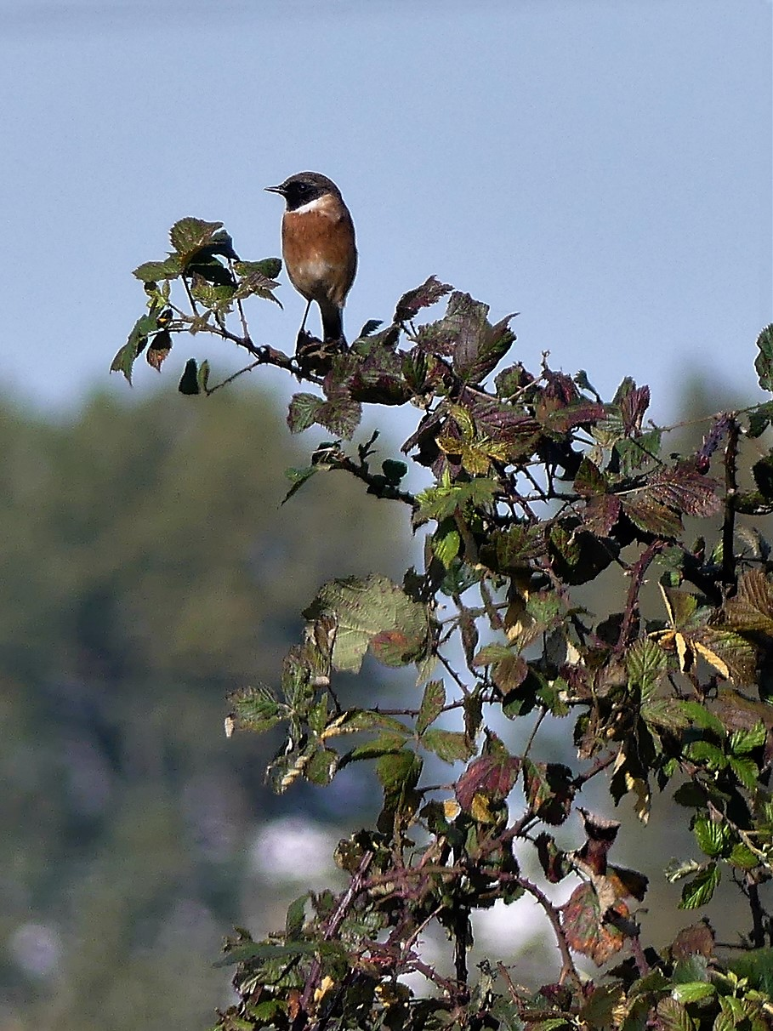
Stonechat

