An introduction to Butterflies: Steve Holmes
I know of only one person who is afraid of butterflies, which is more than can be said for their night-time counterparts, moths! Moths and butterflies both belong to the order Lepidoptera (which originates from the Greek lepis meaning scale and pteron meaning wing); their wings share the common feature of being covered in scales. To explain some differences between butterflies and moths, I’m going to plagiarise my ‘Introduction to… Moths’ article, as follows:
What makes it a butterfly and not a moth? …one of the easier ways to tell the difference is to look at the antennae. In butterflies they are long shafted with a bulb at the end whereas a moth’s are either feathery, hair-like or saw-edged. Butterflies (when not sunning themselves) tend to fold their wings vertically, while moths typically hold them flat, over the abdomen. Some sources cite that butterflies are typically larger and more colourful than their moth counterparts who are basically ‘brown and boring’; something that the Large Emerald and Swallowtail moths would argue against with just cause! Picking up the night-time ‘difference’ it’s true to say that butterflies are primarily diurnal, flying in the daytime, whilst moths are generally nocturnal, flying at night. However, there are whole books dedicated to day flying moths and it’s not unheard of for butterflies to turn up in moth traps… along with many other things!
As with a number of insect groups here in the UK we are ‘blessed’ with many fewer species than most European Countries that lay just across the English Channel or North Sea. Round figures, we have 60 butterflies, Europe 480+… both these figures can likely as not be boosted by vagrants or reduced by local extinctions; either way, there are around eight times more species in Europe than in UK. In real terms, for budding butterfly enthusiasts, 60 is a good thing as there are reasonable chances of identifying just about anything which crosses their path. Identifying any of the smaller number of possibilities available in the UK is eased further by distribution…in Cheshire we don’t have to concern ourselves with those species peculiar to the south coast, nor with those from the highlands of Scotland. In fact, the Cheshire list is in the mid 30’s and grows to the mid 40’s only if you include everything that’s ever crossed our border since substantiated records were collated. So…good news! Unless it’s a complete vagrant hereabouts, all we have to do is eliminate 30-odd species and to do an injustice to Arthur Conan Doyle, “Once you have eliminated all the potentials, whatever you have left must be the one”. Butterflies are therefore a very nice little family to ‘get into’ but it has dangers…if you start and get totally hooked, EasyJet and Ryanair can put you into most parts of Europe for less than the taxi ride from home to Liverpool or Manchester and then your brain is in for a pounding! Depending on where you are, it’s relatively straightforward to see more species in a day than there are on the entire UK list… so let’s stay in Cheshire, it’s less traumatic to begin with!
Butterflies, in tandem with moths, have three life-cycle stages (or four if we include the egg); after hatching larvae begin munching their way through whatever plant their moms have chosen for them, during which time they obviously grow until fully fed. Once ready, they morph into a pupal case, inside of which some miracle of transformation occurs that leads to the final, flying adult stage. I’d be safe in betting that practically everyone has seen adult butterflies but only a small percentage their pupal cases or larvae and a very, very small number the eggs. Thankfully it’s the adult stage which attracts most interest, though some larvae are stunning; for example:
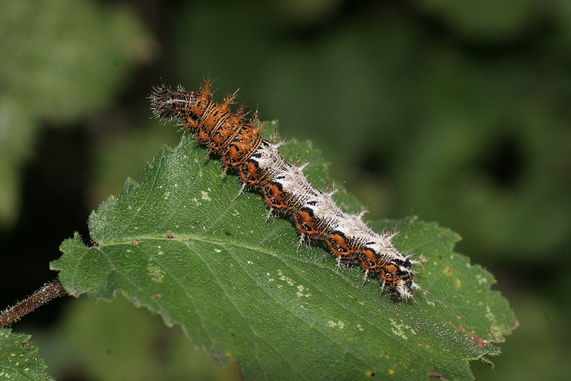
…the larva below (not that regularly found in this species) transforms into the beautiful adult Comma on the right…
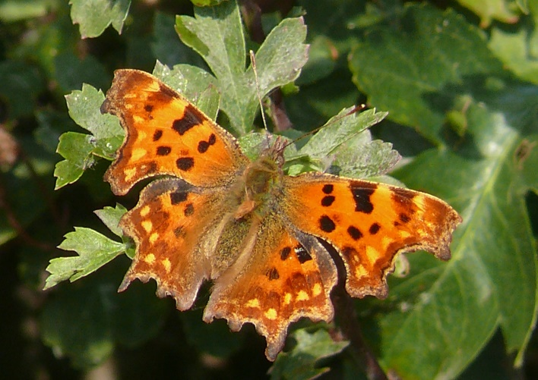

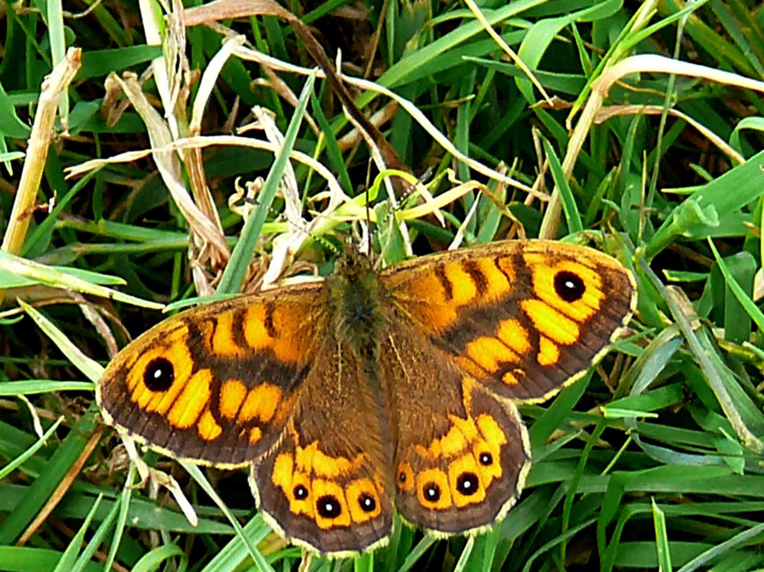
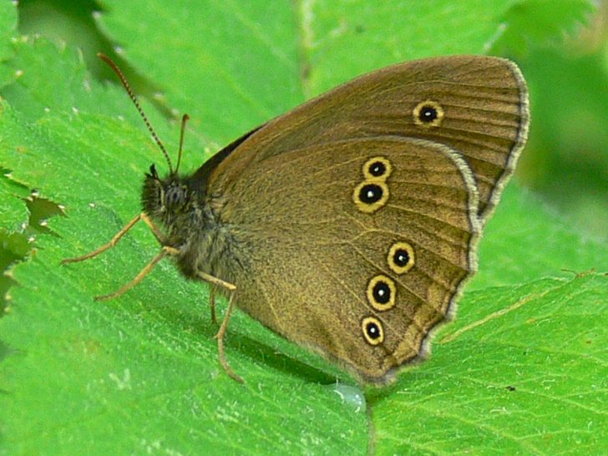
To illustrate our changing environment, over recent times the spread into Cheshire of Ringlet (below, left) has been spectacular to say the least and it’s something to look out for now with reasonable chances of being fortunate. Personally, I’m looking forward to its arrival on Gowy Meadows with great anticipation. It’s not the ‘looker’ that Wall Brown (below, right) is, but given that species continued existence as a Cheshire species is unlikely to be more than a few years before its local extinction, any replacement is welcome.

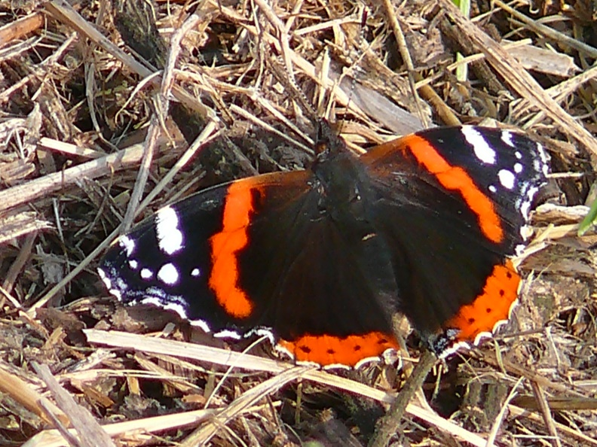
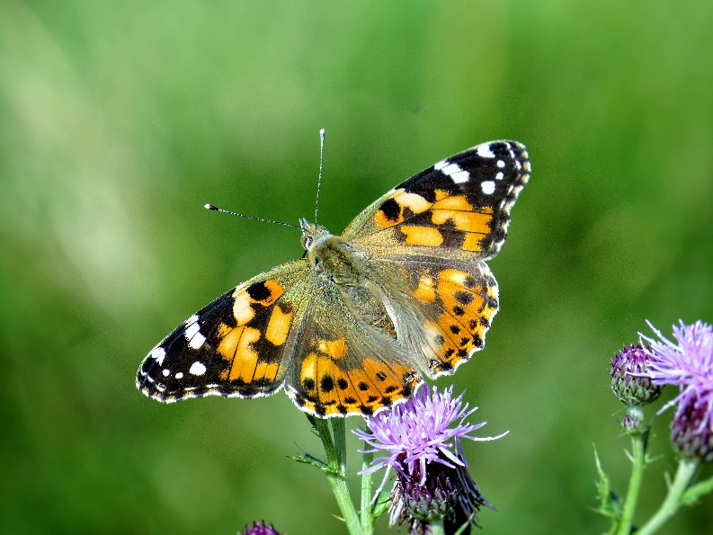
Other than Ringlet, which is probably moving north ahead of warmer weather in its established homelands, there are true migrants – species that for some reason or other arrive here in varying numbers year on year to brighten up our summers. Here, first prize goes unquestionably to Painted Lady, which has been known to turn up in astonishing numbers, breed and the offspring head back south. Its recently been determined that it’s practically a continuous migrant from the tropics of Africa to the Arctic circle, though no one insect ever sees anywhere other than the stage it occupies in the relay; several generations are involved before the species is back in Africa, ready to begin the incredible journey all over again. The Worlds other pan-continental migrant butterfly, the Monarch has in fact also been recorded in Cheshire; its migration from Canada to South America and back pales into practical insignificance when compared to Painted Lady however! Less well known, though readily seen is the southerly autumn migration of Red Admiral. I’ve been fortunate to see this on several occasions over the years with sometimes a few and other times hundreds of insects purposefully beating south without pause. It’s a very special event to witness.

Our butterflies occur in practically any habitat…a nectar source is all they need and as such your own garden will attract several species; my own very small garden has a list of 18, which is about half the Cheshire regulars; you don’t have to travel far to begin enjoying butterflies and you don’t need much by way of equipment either! On European trips, where the number of blues alone can drive you to drink (we have but two in Cheshire) I routinely take a net. This is simply to be able to pot up the catch so as to be able to take photographs and thereafter (hopefully) make a positive identification. Everything is released unharmed. Such a net will cost in the order of £15-25. Some species require examination of tiny areas of their wing so a 10x hand lens is useful, binoculars looked through ‘back to front’ can do a reasonable job. Lenses start at about £12 and are easier to use the magnifying glasses. A few glass or plastic pots will cost practically nothing (nothing at all if you recycle jam jars!) so for about £40 you are good to go. Binoculars are likely as not going to set you back a lot more, they need to be close focusing which tends to up the price too. The point however is that you are not necessarily buying them just for butterfly watching, more for anything natural history related. I use Leica 8*30’s which focus to about six feet. These I use for everything hoverflies, dragonflies and birds alike and they are perfectly fine for all. I’ll not mention the price since they are so old now it’s irrelevant. Suffice it to say that there are multitudes of binoculars out there, made by a number of firms. Some will set you back an arm and a leg, others are ‘more affordable’. Try before you buy to make sure that they are comfortable, both in your hands and to look through and take your time as it’s a serious commitment.
Finally, how to get help with identifications. There are, naturally, huge numbers of books on butterflies – they are a very photogenic tribe and books naturally feed off this fact. Don’t buy anything that needs support from a coffee table! A good quality field guide can still be looked at at home. I use Butterflies of Europe by Tristan Lafranchis…though I believe it is currently out of print. So, use the Internet to see if there are some copies still out there or find a substitute – Collins is always a reliable source for ID guides for example. I mentioned the Internet and of course there are millions of photographs on there of butterflies from all over the world. “UK Butterfly images” typed into Google brought back almost 12 million alternatives… plenty of free help.

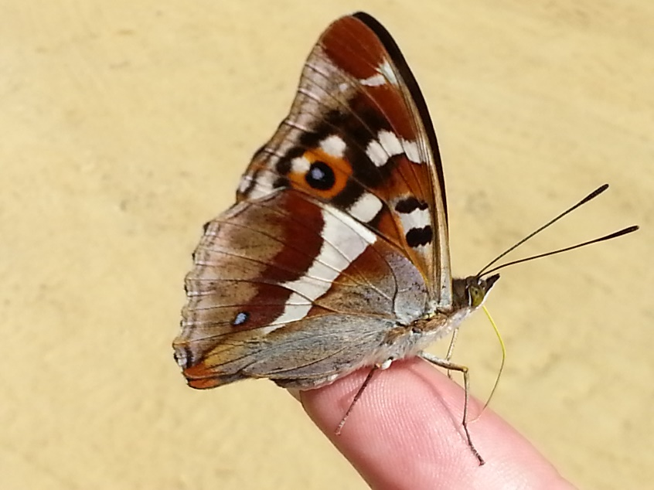
This ex-netted Purple Emperor in Hungary was coaxed onto my hand in the net before eventually being carefully ‘placed’ onto a leaf to photograph in a more natural setting; it’s actually feeding on salts from my ‘sweaty finger’. Incidents such as these are very unusual but when they do happen are much appreciated and certainly bring a smile to everyone’s face.

I do hope this short introduction has proven useful in kindling an ember into life, good hunting!
