An introduction to Gall Causers: Steve Holmes
OK, I can hear it…”What on earth is a gall causer…and whilst on the subject, what’s a gall!?” Good questions, and thankfully both are straightforward to answer. Plant galls are structures, often beautifully intricate but sometimes more prosaic, resulting from the interaction between a plant and some other organism. ‘Organism’ in this context is interchangeable with bacteria, fungus and invertebrates amongst other things and the UK has in excess of 1,000 examples of these weird and often wonderful collaborations – though the plant can be seen as nothing more than a host that gains nothing from the event.
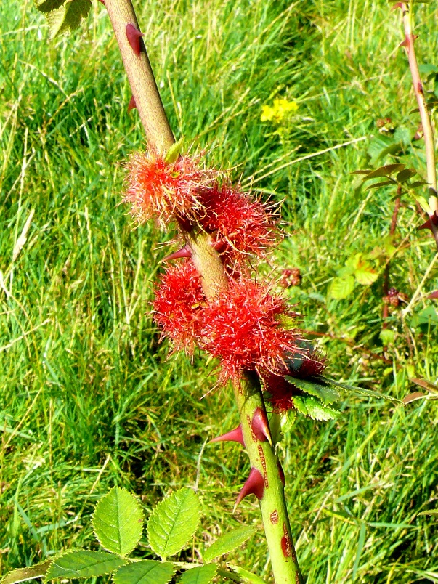
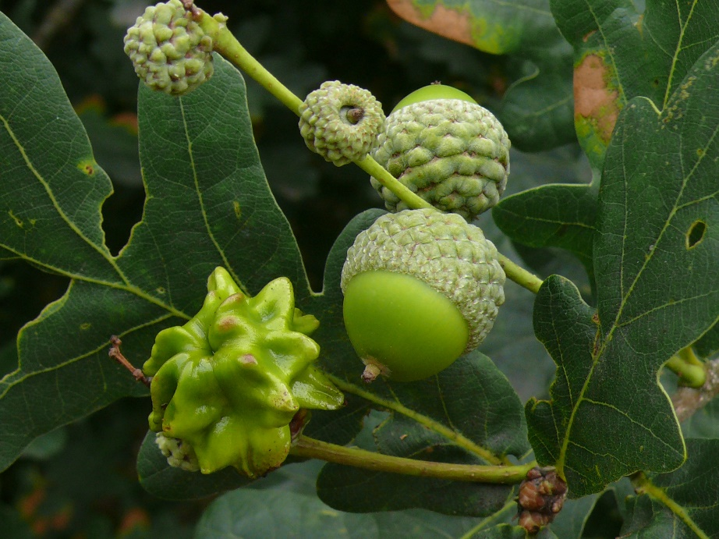
“I’ve never seen one, so how easy are they to find?” is a statement which gets “You probably have seen some” as part of its answer as anyone taking more than a passing interest in an Oak tree in summer will almost certainly have seen examples of the so-called Knopper Gall seemingly stuck to the side of acorns, or Robin’s pincushion on wild rose.
These are respectively ‘caused’ by the gall wasps Andricus quercuscalicis and Diplolepsis rosae. Unfortunately, gall causers are another bunch of critters that invariably have no English name; we’re into scientifics only again.
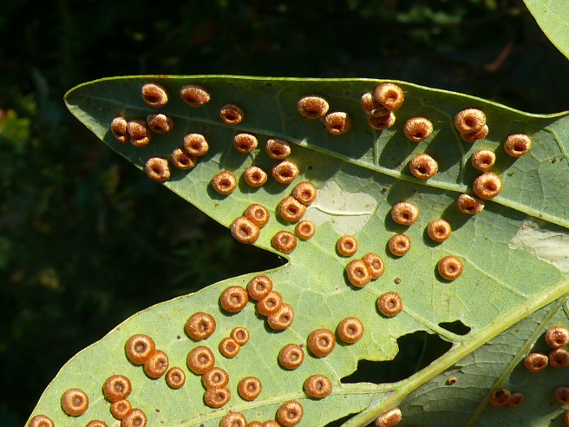
Gaul causers use a multitude of plant hosts, ranging from one end of the spectrum with Oak trees to stinging nettles at the other and practically everything in between. Oaks are particularly well liked and galls are remarkable simple to find once in season (basically when leaves have appeared!) looking for out of place shapes being the easiest method. Turning leaves over of course is equally profitable. Two early autumn Oak galls are very common and can completely cover the undersides of leaves, these are Neuroterus quercusbaccarum and Neuroterus numismalis or as I prefer to call them, fried eggs and donuts! Note that in the photograph on the right there’s a micro-moth leaf mine…something covered in another article!

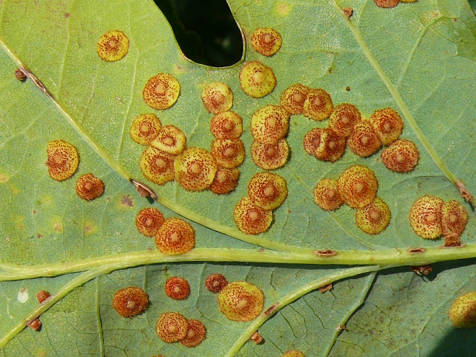

In essence, anything looking as if it ought not to be where it is on a plant…micro-moth larval cases notwithstanding…is likely to be a plant gall. How you find out what it might be is down to two essential pieces of information; what plant is it on and what does it look like. Accordingly, a photograph ought to be enough to get you half way there – the other half is where to find the required information needed to separate out what’s in your photograph from all the other possibilities
The internet is of course available to almost everyone these days so typing something like “UK Plant galls on <insert plant name here>” into Google should bring back several, if not numerous alternatives. There are of books available, though not so many –gall causers aren’t exactly a high profile interest! An excellent introductory full colour guide “Britain’s Plant Galls” by Michael Chinery, from the equally excellent WildGuides stable will not empty your wallet of more than a few ££’s, so if it gets your interest going you will have enough to acquire “British Plant Galls”, authored by Margaret Redfern and Peter Shirley, courtesy of the Field Studies Council. The latter isn’t something you would want to take out into the field and though it has some colour drawings it’s mainly a reference book, containing as it does over 200 keys to many causer groups. ‘Chinery’ has many photographs of galls taken in the field and is light and small enough for a pocket.
So, where does that leave us… well you can of course go out and start looking for these curious ‘constructions’ in isolation or perhaps an approach based on whilst watching perched insects you simply look beyond them at the leaf or stem might better suit. The latter method may also result in an interest in leaf-mining insects, which would be no bad thing as they are another under-recorded set. The only downside to all the above is unfortunately that you aren’t particularly likely to see the adult “causer” since most are microscopically small. Nonetheless, presence of galls is proof enough to see another helpful ‘dot’ in the distribution maps for whatever it is, which in turn furthers our knowledge and understanding of it

