Concise status of the
Butterflies and Dragonflies of
Cheshire Wildlife Trust’s
Gowy Meadows Reserve

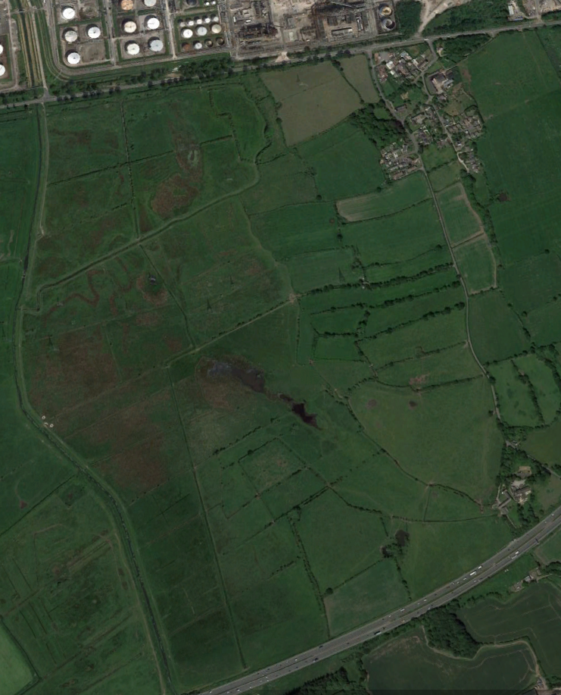

Up to mid-August 2017 the species listed below have all been recorded on the Trust’s reserve at Gowy Meadows, adjacent to Thornton-le-Moors. It has been prepared to give an indication as to what opportunities there are regarding butterfly and dragonfly species possible to see if the reserve is visited by the casual observer. With one or two exceptions, information used to base species’ assessments on has been accrued over the period March 2004 to August 2017.

BUTTERFLIES

Large White Pieris brassicae: Recorded every year, between April and October. Can be common but less so in recent years. Can sometimes be seen in relatively large numbers (hundreds) under optimal conditions.

Small White Artogeia rapae: Much the rarest of the three so-called common ‘whites’ despite being see in every year. This species has declined markedly over 2012-2017 to a point where it’s now a good find. Flight period spans March to September.

Green-veined White Artogeia napi: Records from every year apart from 2006 for some reason. Massively the commonest white, with numbers suggesting it to be twice as numerous as Large White and four times commoner than Small White. However, the reality is that of late its numbers dwarf those of virtually every other species on the reserve apart from Meadow Brown.

Orange Tip Anthocharis cardamines: Seen in every year apart from 2005, between 2nd April and 4th June. The recent average is just over 100 per year with the large majority of records understandably referring to males.

Clouded Yellow Colias crocea: Vagrant, the only record concerns a single on October 3rd 2009.

Brimstone Gonepteryx rhamni: Unrecorded prior to 2009, this is currently a species slightly on the increase. Records span 19th April to 21st September, but it remains a very rare species on the reserve. Invariably males.

Purple Hairstreak Quercusia quercus: Though certainly a resident, breeding species it has only been recorded in 2011, 2013 and 2017 and unfortunately in locations away from public access.

Small Copper Lycaena phlaeas: Seen every year but in very small numbers generally (21 is the maximum ever on a single day), between May and October. Much commoner in autumn than spring.

Holly Blue Celastrina argiolus: Averages sightings approximately every other year thanks to fluctuations in population. Not quite a vagrant but very close. Recorded in April, May and July-August.

Common Blue Polyommatus icarus: Scarce resident in small numbers. Recorded in most years, between May and September. The most in a single day is 13.

Peacock Butterfly Inachis io: Reasonably common resident in small numbers; seen every year between March and October, with the early records referring to overwintering adults. Numerically, the 5th commonest species on the reserve but many individuals accounted for through the finding of bunches of larvae.

Red Admiral Vanessa atalanta: Uncommon resident and partial autumn migrant on occasion (up to 33 in October being part of a wider instance). Early spring records are rare and assumed to be over-wintering adults. Latest date recorded is 1st November.

Painted Lady Vanessa cardui: Almost annual since 2009 in fluctuating numbers as dictated by the year’s immigration from Africa. Records span April to September with a highest day count of just eight.

Small Tortoiseshell Aglais urticae: Fourth commonest butterfly on the reserve though again, the situation is clouded by the finding of groups of larvae on occasion. Larvae apart, there have been three counts of 100+, with the peak being 237. One of several species which find purple thistles to their liking and which can be seen attending them in their dozens.

Comma Butterfly Polygonia c-album: Scarce resident seen virtually every year and then mostly in autumn. Records span March to October.

Meadow Brown Maniola jurtina: By far the commonest species on the reserve, seen every year between June and September. Three figure counts are regular but in truth the actual numbers are practically impossible to quantify as just about any field can see individuals flushing from underfoot at just about every step taken.

Gatekeeper Pyronia tithonus: Despite a relatively short flight period (3rd July to 29th August) it can be very common during those times, when up to 241 have been seen in a day. As with Meadow Brown, it would be difficult to accurately assess true numbers as they can turn up just about anywhere on the reserve in numbers.

Speckled Wood Pararge aegeria: Seen every year in small to moderate numbers between April and October. Can be anticipated just about anywhere but the prime sites are unfortunately away from public access. All the largest counts come from mid-August onwards, when up to 28 have been seen in a day.

Wall Brown Lasiommata megera: Sadly, now extinct on the reserve with the last record on 29th June 2014. Its two broods were recorded in May-June and August-September with the latter much the larger. Up to 23 in a day in early August 2009 was the all-time peak.

Small Skipper Thymelicus sylvestris: Virtually annual in small numbers between June and August. The peak count is of 60 on July 11th 2013.

Large Skipper Ochlodes venatus: Similar to Small Skipper, though on the wing slightly earlier, with some records in May. The peak count is of 25 on 12th June 2014.

Possible additional species:

The Ringlet Aphantopus hyperantus is a recent colonist within Cheshire and its appearance on Gowy Meadows is simply a matter of time.

DRAGONFLIES
Banded Demoiselle Calopteryx splendens: The Gowy and a few of the minor watercourses on the reserve hold thriving colonies of this stunning species which can reach numbers of super abundance in some years. Difficult to miss between late May and mid-August, though there have been records of individuals into the first week of October. Three figure counts are commonplace and the peak is of 3400 along a 500 metre transect in June 2015.

Blue-tailed Damselfly Ischnura elegans: Seen every year between late April and late August when it can be common but numbers appear to be declining of late, though can be expected anywhere including away from water.

Common Blue Damselfly Enallagma cyathigerum: Just about annual (no records in 2016) in very small numbers (up to 20). All records come from sites away from public access.

Azure Damselfly Coenagrion puella: Common to very common resident seen every year between late April and early August. Can be expected anywhere including away from water; peak count is of 179 on 1st June 2014. Second commonest dragonfly after Banded Demoiselle.

Red-eyed Damselfly Erythromma najas: Vagrant: Two records of singles in June 2010 were thought to be the forerunners of colonisation (supported by another record close by in the same year in May) but sadly has not been recorded since despite careful searching.
Large Red Damselfly Pyrrhosoma nymphula: Seen every year between late April and late July and invariably the first dragonfly to appear each year. Widespread, including away from water but generally in small numbers of up to 30. Peak count is 59 in a single day.

Migrant Hawker Aeshna mixta: Uncommon visitor seen every year between late July and late October in very small numbers. Can be seen anywhere but more likely patrolling a hedgerow than over the Gowy or other watercourses. Peak count in a day is just 10 on 28th September 2014.

Brown Hawker Aeshna grandis: Scarce resident in very small numbers seen every year between mid-June and mid-October. Mainly over the Gowy or other major watercourses on the reserve. Peak count is of just 10 on 22nd August 2009.

Southern Hawker Aeshna cyanea: Scarce, presumed resident in very small numbers. Recorded every year between mid-June and mid-October with a peak of just three on any one day. Rarely seen away from the Gowy.

Common Hawker Aeshna juncea: Vagrant: just six records between mid-June and mid-September but not seen since 2013.

Emperor Dragonfly Anax imperator: Scarce resident seen annually since first arriving in 2007. Seen between early June and mid-September, mainly over the Gowy but can frequent other watercourses. Peak day count is nine.

Four-spotted Chaser Libellula quadrimaculata: Uncommon resident seen every year between mid-May and early August with a peak count of 19 on 22nd June 2014. Minor watercourses seem preferred over the Gowy.

Broad-bodied Chaser Libellula depressa: Rare visitor in very small numbers between late April and late August, though it is recorded every year. The peak is just five (9th June 2007). Minor watercourses also seem preferred over the Gowy.

Black-tailed Skimmer Orthetrum cancellatum: Very rare visitor unrecorded before 2007. Records average two years out of three, when individuals have been seen between late May and late July. The maximum day count is of four on 20th July 2008.

Ruddy Darter Sympetrum sanguineum: Very rare, potential resident that may go un-recorded in some years due to the tiny population likely present. Records average every other year though it hasn’t been seen since 2015, span late June to late September with two the most seen in a day; a good percentage of all records are away from water.

Common Darter Sympetrum striolatum: Relatively common species seen every year between early June and late September, though there is a distinct bias towards autumn records. Peak count is of 53 on 21st September 2013.

Possible additional species:
Beautiful Demoiselle Calopteryx virgo: A single individual was seen on the Gowy immediately to the south of the motorway on 7th June 2008 but the likelihood of further sightings seem remote.
Variable Damselfly Coenagrion pulchellum: A small colony exists in the ditch system just south of the motorway and as such it has the potential to appear on the reserve in the future. However, the colony hasn’t been looked for since 2013 so may even no longer exist.

Black Darter Sympetrum danae: Two local records concerned singles seen on 13th July 2008 and 1st October 2006 – both within a mile of the reserve.

