An introduction to leaf-mining micro-moths: Steve Holmes
Some larger micro-moths boast a forewing length of up to 20 millimetres but for the most-part and what makes the group such a challenge to identify, you have to contend with insects with wing lengths no more than three or four millimetres. To make matters worse, some families (Nepticulidae and Coleophoridae to name but two) are large, with scores of UK representatives. The chances of actually finding a nepticulid, even if it’s in your moth trap, aren’t that high! Even if you do, identification based on external features is virtually impossible. A tiny proportion of moth trappers resort to dissection and examination of genitalia, but even then, some individuals remain undetermined. Yes, micro-moths aren’t for the feint hearted! Fear not, salvation comes in the form of leaf-mines, through which a large number of species can, in many instances, readily be identified.
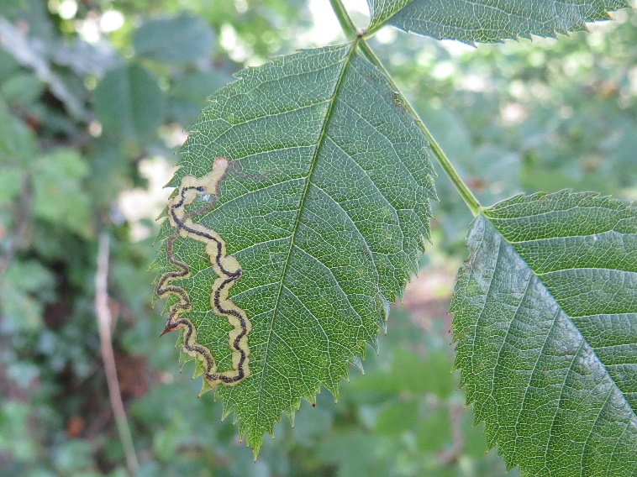
So, what is a leaf mine? Simply put, they are the tracks made by the larval stage of certain micro-moths and some flies – by no means do ALL micros or flies ‘mine’. In truth, some of the ‘miners’ don’t either, but more of that later for the moment, here’s a mine. In simple terms, what the mine represents is exactly where the larva has been feeding, between the upper and lower epidermis layers; the dark line is of course larval poop! Poop is actually a good method of distinguishing between moth and fly mines; fly poop is deposited by a larva that is forever twisting its body around inside the leaf so its normally seen as ‘footprints’ rather than as in the photograph (showing the mine of Stigmella anomalella), the continuous line of a ‘straight ahead’ moth larva.
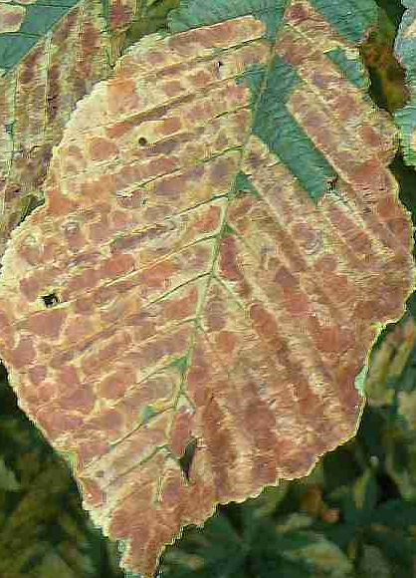
At this point I’d be inclined to think that most readers will now be saying to themselves…”Yes, I’ve seen those lines – I just didn’t know what they were”. They are in fact quite a common sight and some species are super abundant with mines plastered all over every leaf on the tree. Below left, the mines of Lyonetia clerkella long sinuous and above all, numerous. To the right Camararia ohridella, the infamous Horse Chestnut leaf miner. Clerkella can be found on a number of host plants, but were initially apple only; ohridella arrived in Cheshire as recently as 2005 and if you can find a conker tree these days which hasn’t been discovered by them you will have found a rare tree indeed.
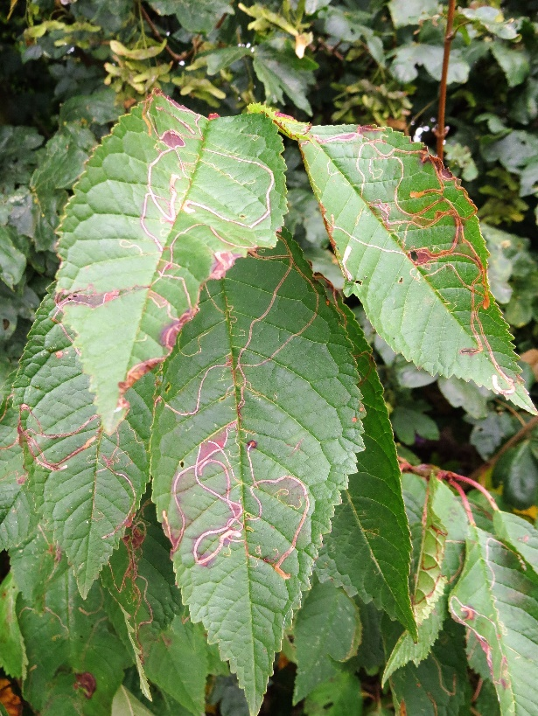

On dull days in the field I’ve attempted to calculate numbers of mines simultaneously on view of these species; from memory, on three chestnut trees there were over 450,000 ohridella mines and on one hornbeam, 5,000 clerkella mines! Essentially, the linear mines are not that difficult to find; they occur on any number of trees, bushes, shrubs and even some grasses. Once you have the host plant, the size, shape, poop, location of the egg (upper or underside) and the larva will tie down large numbers to species, including many nepticulids so don’t worry too much about not finding the one that was in your moth trap! However, there are other forms of ‘mine’. Some species simply fold over a leaf edge, others form ‘creases’ and yet more build themselves a house and wander around inside it making forays into the leaf when hungry; one at least actually uses a seed-head of Mugwort as its mobile home. These other tribes are bound by the same basic rules as above however though since there is no ‘linear mine’ it’s more important to study the shape, fold or mobile home (aka larval case) as well as identifying the host plant.
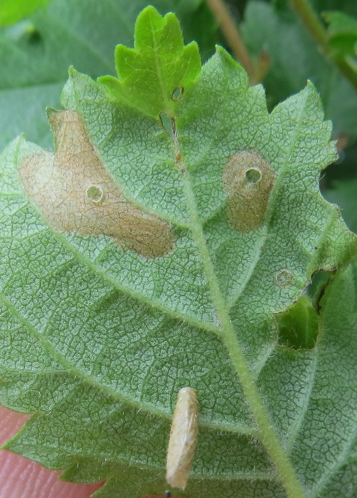
Members of the Coleophoridae are the home, or case makers. They come in all shapes and sizes and though some are straightforward enough to find, others are less so. The photograph to the right shows a case of Coleophora serratella, one of the easier finds. This particular one is on the underside of the leaf but it can just as easily be on the upperside or even on the leaf stem (petiole) itself. Previous stints of feeding can also be seen above the case, each one with a tiny hole, through which the larva entered the leaf to feed before reversing backwards into the relative safety of its case. Oftentimes it’s the feeding evidence that leads to the discovery of a case as the upperside of the leaf can be peppered with pale areas within which there is a clear darker spot; the entry hole into the leaf. Once you have your eye in, the finding of cases is also easier.

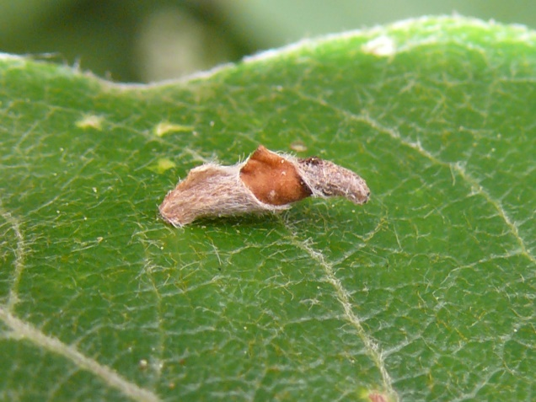

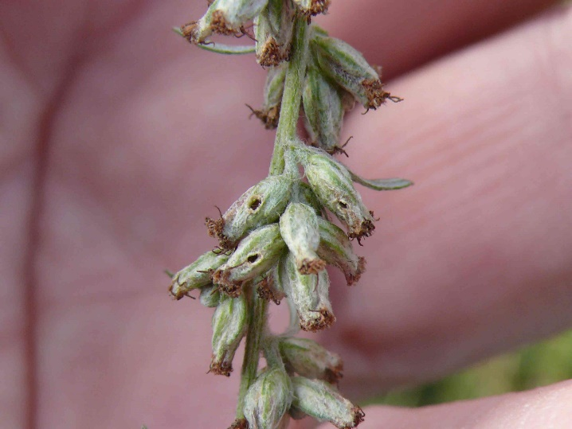
Some can be very beautiful structures and are well worth the effort to find. The one to the right is of Coleophora lusciniaepennella, whilst below right is a seed-head of Mugwort, occupied by the larva of Coleophora artemisicolella. These are more easily found when the seedheads are brown, rather than green as the feeding holes (below) in seeds which have already been visited are easier to find than the inhabited one.

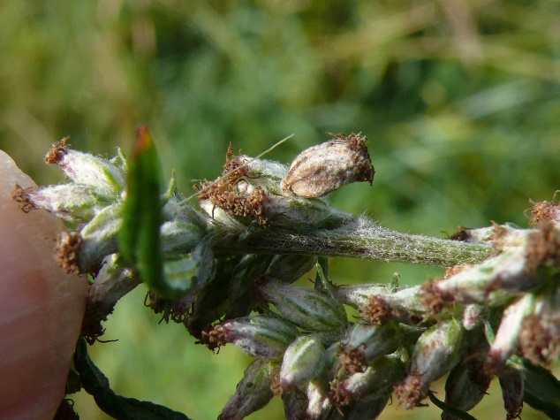

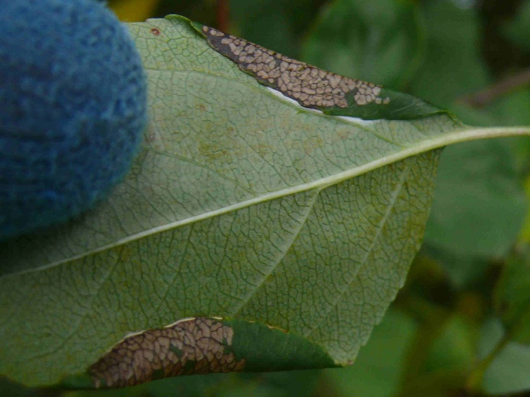
Folds, creases and blisters are other tell-tale signs made by micro-moths on leaves and through finding them, another batch of species can be identified, some more easily than others. In the photograph to the right there are two folds, both made by Calisto denticulella; the fact that my hand was gloved at the time is mute testimony to the fact that it was a cold day – 30th September!

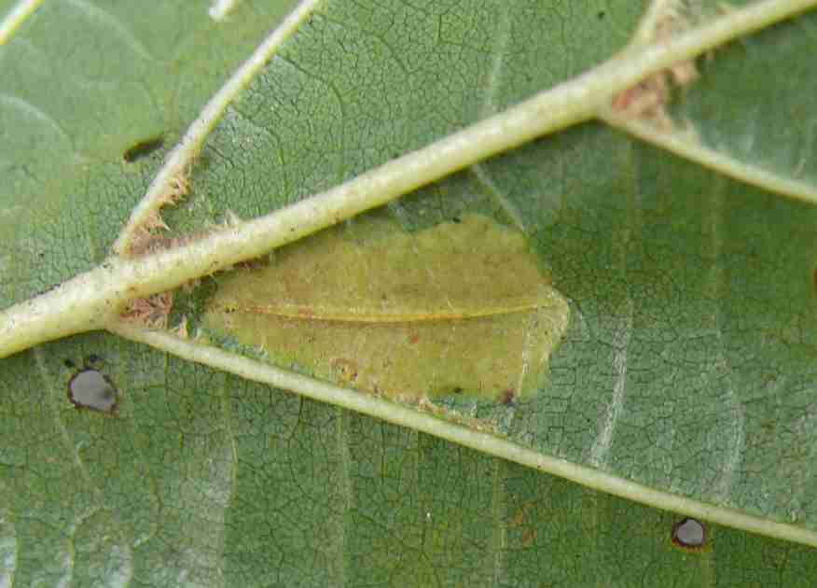
Creases in leaves are generally made by one of the Phyllonorycter species, of which there are dozens on the Cheshire list. Equally, they are ordinarily on leaf undersides though they can easily be seen on the upper surfaces as distortions. One or two additional rules apply to creases, namely length and number of creases in the ‘mine’. In the case to the right, Phyllonorycter rajella, there is just one, strong crease; other species typically show more.

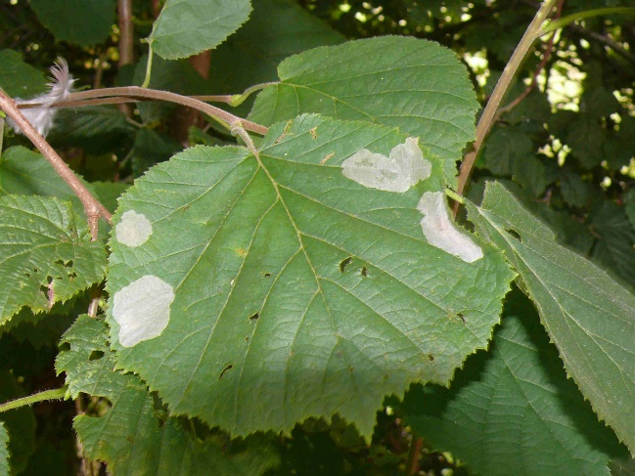
Though there are only a few ‘blister miners’, some can be commonplace given the right host plant is available. Pyracantha owners may have noticed long blisters along the leaf midrib – sure signs that the miner Phyllonorycter leucographella is in your garden; many leaves may host blisters too, as they are common enough moth. In the photograph to the right, a single hazel leaf is hosting four or five larvae in blisters made by Phyllonorycter coryli.

OK, so we’ve covered off the main types of mine so now the main unanswered question is “when can I look for and expect to find mines and cases?” The simple answer is, when there are leaves for them to use. In reality however, there are a flush of species in spring and as the year moves on a few more become lively but its late August to October when most activity occurs. In September it’s entirely possible to record upwards of 70 species in a single day, the vast majority of which would be difficult to impossible to identify through seeing the flying adult. Later on in the year, despite mines still being around, it becomes increasingly difficult to be sure of the actual species responsible as appearances can change with age. However, some species’ mines, such as those on evergreens like bramble, persist and remain distinguishable. Blackberry pickers should be on the lookout therefore as there are several species which mine bramble – though not all occur in Cheshire. The entire field of leaf-mining is moving feast; new discoveries are causing us to re-think identifications or in some cases to discard them altogether as characteristics once taken to be categorical evidence have been found wanting.

As such, the following criteria should be noted when in the field:
- Host plant species
- Position of the egg – if it’s still present of course
- If the mine is still tenanted, a description of the larva is very helpful
- Description of the frass (poop!)
It may seem unreasonable to be expected to find an egg which will be about the size of a grain of sand, but it’s really not as difficult as it sounds. For one thing, it’s always going to be at the start of the mine, so just look there – on both sides of the leaf…if it’s present, you will find it. Photographs are of course extremely helpful, essential really and this day and age, mobile phones are more than good enough…on the plus side, the subject matter isn’t going anywhere fast so you can take time in making sure what you take is good quality. In the case of ‘crease makers’ upper and underside photographs can be as useful as each other in securing an identification.
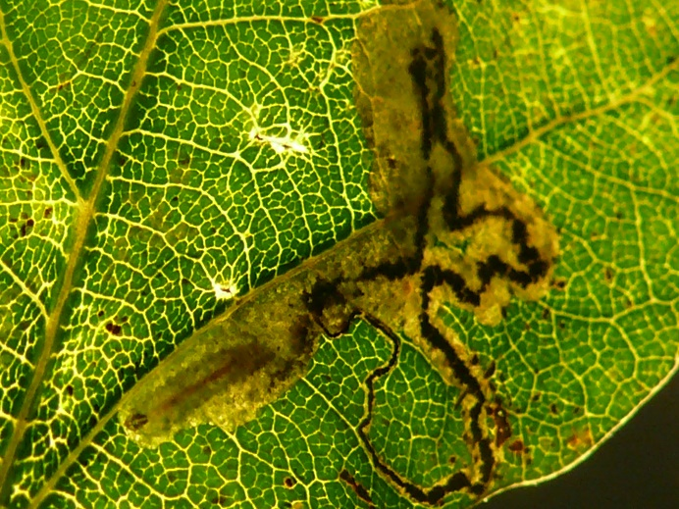
For photographing larvae, just hold the leaf up to the light and fire away. In the photograph to the right, the larva is easily visible at lower left, together with the frass line that’s decreasing in width back along the track to where ultimately the egg would be.
In terms of equipment ‘required’ for leaf-mining, it may turn out to be nothing in addition to what you already own; some form of camera and a hand lens. The latter I’d say was essential as though you can use binoculars ‘back-to front’ you need to be closer to the leaf than they allow. For identifications, there are bespoke websites for leaf mines; I use:
http://www.leafmines.co.uk/index.htm , and
http://www.ukflymines.co.uk/ within which Lepidoptera are well covered. There’s also:
http://www.record-lrc.co.uk/ which is an excellent website that hosts dozens of forums, the one for moths being by far the most active. To access it, select ‘News’ from the top line of categories, then ‘Forum’ and scroll down to moths. Posting of photographs for potential identification is commonplace from first timers to experienced moth people, so have no concerns about tapping into the knowledge base that’s available.
Leaf mines are another area which will slow down your progress when out walking but they are a very interesting subject which to get involved with. Have fun.

