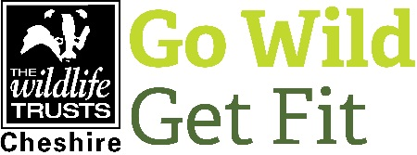
TRAINEE ROLE DESCRIPTION

POST TITLE Natural Wellbeing Trainee
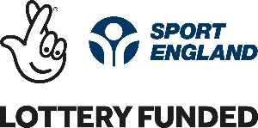
FUNCTION To support the delivery of the Go Wild Get Fit project.
MAIN CONTACT Natural Wellbeing Project Manager
COMMITMENT Between 2-3 days a week for up to 12 months
LOCATION Central Cheshire but travel to Bickley Hall Farm, SY14 8EF and Holly Bank House, CH2 4HU will be required.

THE PROJECT
Our Sport England funded project, Go Wild Get Fit uses conservation volunteering to provide development opportunities for those who are disadvantaged or disabled within the deprived locations of Northwich, Winsford, Chester and Ellesmere Port. It helps people focus on one of four goals with the support of mentors:
- Improved wellbeing
- Improved fitness
- Transition to education, training or employment
- Progression onto regular volunteering
THE TRAINEESHIP
This is a unique opportunity to gain experience and skills within natural wellbeing. Green and social prescribing are becoming more popular and now is the time to develop the skills you need to get into the sector. By volunteering you will engage with vulnerable adults, support the delivery of practical volunteering sessions and help monitor the project’s success.
MAIN TASKS
- Support the development of vulnerable adults to reach their goals
- Co-ordinate and support the delivery of volunteer days
- Complete practical habitat management tasks including but not limited to:
  - Path and access improvements
  - Wildlife gardening
  - Tree planting
  - Invasive species control
- Innovate creative delivery methods to get the best engagement results
- Collect and analyse data from volunteers
- Support monitoring of the project’s success
- Various administrative support
PERSON SPECIFICATION
We are looking for someone with the following qualities and abilities:
- A passion for wildlife and conservation
- An affinity for the benefit the outdoor activity can have on wellbeing
- Enjoys being outdoors
- Enjoys engaging with the public
- A willingness to engage with disadvantaged or vulnerable adults
- Reliable, proactive, passionate and able to use initiative
- Experience with Microsoft packages particularly excel
- Willingness to support with data entry and analysis

PRACTICAL ARRANGEMENTS
- This is a 9-12 month volunteer traineeship. Flexible days can be accommodated.
- The Natural Wellbeing Project Management will set your work programme. We can tailor your work programme to help you gain the skills you need.
- Reasonable travel expenses will be reimbursed up to a maximum agreed limit.
- We will ask for one reference before you begin volunteering with us (this can be a teacher or lecturer), your continuation in the role is subject to satisfactory completion of a three-month trial period and continued good conduct and attendance.
- The normal working day for CWT is 9am to 5pm, Monday to Friday but we may occasionally ask you to help out outside these hours.
- You will need to have a reasonable level of fitness and mobility and be able to spend a significant amount of time outside, often on difficult terrain.
- You will be based at Holly Bank House, Thornton-le-Moors, Cheshire CH2 4HU although you will be off site on many occasions and expected to travel to Bickley Hall Farm, SY14 8EF.
- Due to the nature of this project, the post-holder must have a full driving licence and access to a vehicle.
- A DBS may be required

BENEFITS AND TRAINING
- You will be supported to create a learning plan.
- Training needs will be identified at the time of setting the learning plan and will be arranged at an appropriate time.
- Free access to CWT internal training courses.
- Small budget for external training courses.
- Gain experience in practical conservation tasks, community engagement activities within an experienced team.
- Gain experience within an environmental organisation.
- Help with CV / job applications.

APPLICATION
If you are interested in this volunteer role then please complete a trainee application form and email (along with your CV) to Emma Raine (eraine@cheshirewt.org.uk). If successful you will be invited down for an informal interview.
Closing date:
Please ensure your completed Trainee Application form (along with your CV) is received by midnight Sunday 10th November.

