

**Wildlife sightings at Cleaver**

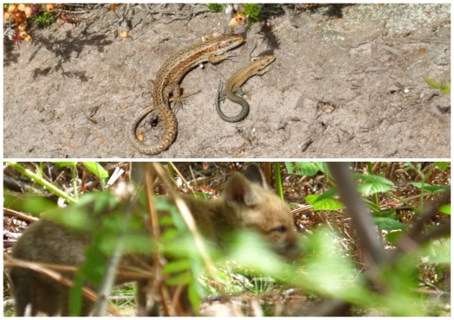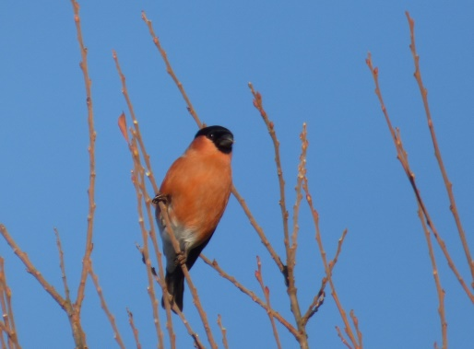

**Amphibians & Reptiles**

Common Lizard

Common Frog

Common Toad

**Butterflies & Moths**

Small White

Large White

Green-veined White

Orange-tip

Peacock

Speckled Wood

Small Heath

Gatekeeper

Meadow Brown

Comma

Small Skipper

Small Copper

Common Blue

Holly Blue

Painted Lady

Red Admiral

Emperor Moth

Cinnabar Moth

*Alan Irving*

*Volunteer Reserve Warden*

*Cleaver Heath*

**Invertebrates**

Brown-lipped Banded Snail

Honey Bee

Red-tailed Bumble Bee

Buff-tailed Bumble Bee

Marble Gall Wasp

Ichneumon Wasp

Swollen-thighed Beetle

Brown Hawker

Southern Hawker

**Mammals**

Badger

Fox

Field Vole

Wood Mouse

Common Shrew

Grey Squirrel

Common Pipistrelle

Soprano Pipistrelle

Noctule

**Birds**

Blackcap (S)

Bullfinch

Buzzard

Chaffinch

Chiffchaff (S)

Collared Dove

Fieldfare (W)

Goldcrest

Goldfinch

Greenfinch

Green Woodpecker

Great Spotted Woodpecker

House Martin (S)

Jay

Kestrel

Linnet

Long-tailed Tit

Mistle Thrush

Nuthatch

Redwing (W)

Song Thrush

Sparrowhawk

Swallow (S)

Swift (S)

Whitethroat (S)

Willow Warbler (S)

Woodcock (W)

Woodpigeon

Wren

*(S) Summer visitor*

*(W) Winter Visitor*

Around **50 species of birds** have been recorded at Cleaver in recent years. You may also be lucky enough to see some of our mammals, amphibians, reptiles, butterflies and other insects. Some of these species are listed below.