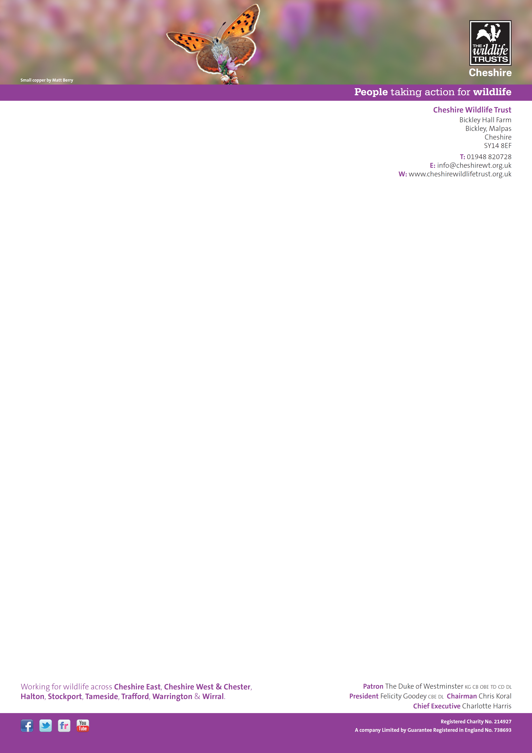
FAO Nick Turpin
Planning Department
Cheshire East Council
PO Box 606
Crewe CW1 9HP
planning@cheshireeast.gov.uk

Dear Mr Turpin, 8th December 2014
Application 14/0282M, Land off Congleton Road, Macclesfield
The Cheshire Wildlife Trust currently wishes to object to planning application 14/0282M, Land off Congleton Road, Macclesfield.
The size, location and nature of this proposal means that it clearly meets the selection criteria for Schedule 2 developments which are set out in Schedule 3 of The Town and Country Planning (Environmental Impact Assessment) Regulations 2011. Therefore, under regulation 3, this planning proposal cannot be lawfully determined without an accompanying Environmental Statement.

Yours sincerely,
R.J. Giles

Rachel Giles Ph.D.
Ecology and Planning Officer
Cheshire Wildlife Trust

