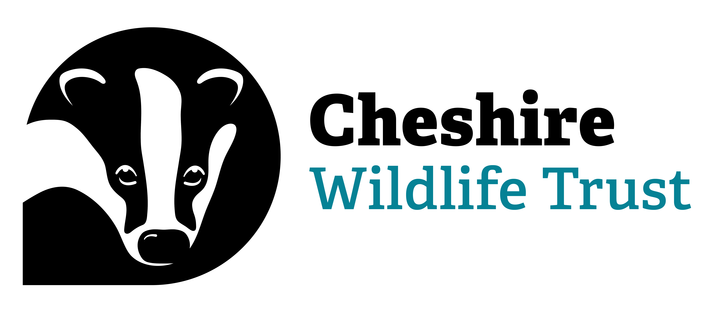

Local Wildlife Site Record

Information Request and Terms & Conditions Agreement
Cheshire Wildlife Trust requests that you complete this form before we can release the relevant data that we hold.

Company details
Name:
Organisation:
Address:
Telephone:
E-mail:

Invoice details
Invoice to be e-mailed to:
Purchase Order Number:

Project details
Project / site name:
Project / job number:
OS grid reference:
Search radius required:
Purpose of enquiry:
Standard search options and associated charges (PLEASE TICK WHICH YOU REQUIRE)
Please note: While the information from Cheshire Wildlife Trust itself is free, these charges cover the cost of supplying the information and administrating the Local Wildlife Site system. Charges may be reduced for non-commercial enquiries. Cheshire Wildlife Trust reserves the right to vary these charges without prior notice.
- Basic Search
£75 + VAT
• Results map of site for 1km search for Non Statutory (Local Wildlife Sites) sites including potential Local Wildlife Sites
- Detailed Search
£150 + VAT
• Results map of site for 1km search for Statutory and Non Statutory sites including potential Local Wildlife Sites, Priority Habitats, Peatland data (where applicable).
• Information regarding Statutory and Non Statutory sites including designation features
• Any other information that might be related (e.g. Land Cover data)
We aim to complete and send the results of an average enquiry within 10 working days from receipt of this signed agreement. For urgent enquiries an expediation charge is levied
- Expediation Service
- same day where possible 50% of total cost
- within 2 working days 20% of total cost

Terms and Conditions
- By returning a signed copy of these conditions, users agree to adhere to the Terms and Conditions and to pay the associated fee for the data provided. In the event of a search enquiry being cancelled, Cheshire Wildlife Trust reserves the right to charge for any work already undertaken.
- Cheshire Wildlife Trust is committed to the protection, conservation and enhancement of the natural environment. Information is provided pursuant to Section 141 of the Local Government Act 1972, and the Environmental Information Regulations 1992. To this end, users of Local Wildlife Sites data are required to inform the Service in writing of the purpose and location of their enquiry and the use to which the information will be put.
- It is not the intention of Cheshire Wildlife Trust to provide environmental information where the disclosure of such information would increase the likelihood of damage to the environment. Permission to use the LWS Record may be refused on the grounds of confidentiality or sensitivity, or if it were believed that access to the information would be detrimental to the natural heritage.
- Local wildlife sites information and/or data sets are supplied on the understanding that they are for the sole use of the enquirer only and should not be sold, copied or passed on to any third party without our express permission, except within reports which constitute a part of the original purpose of enquiry stated in this agreement.
- Due acknowledgement of the LWS Record provided by Cheshire Wildlife Trust will be given in any publication or report which has made use of its data.
- Information on Local Wildlife Sites should not be incorporated in any database or electronic retrieval system without written permission from Cheshire Wildlife Trust.
- Data is accurate at the time of supply. LWS are reviewed annually by the LWS partnership. The LWS record is updated with any changes accordingly. While every effort has been made to verify information contained in the LWS Record, Cheshire Wildlife Trust cannot accept responsibility for the accuracy of any particular piece of information. Boundaries of sites should be considered as indicative and not definitive.
- Users of the LWS Record will be expected to inform the Cheshire Wildlife Trust of new sites or information which may come to light as a result of their research. Copies of, or access to, the research is also to be made available.
- The request for LWS Record data cannot be stated to be a consultation with Cheshire Wildlife Trust on a particular development.
- Cheshire Wildlife Trust does not hold comprehensive information on species records, protected or otherwise, as this is held by the local biological records centre. Cheshire Wildlife Trust will only provide details of Local Wildlife Sites. This cannot be considered to be a full biological record search, nor does it exclude the presence of other biological records in the search area.
- Cheshire Wildlife Trust accepts that there may be a requirement to treat certain enquiries with confidence. Equally, it is expected that users will not pass on information in an irresponsible or unethical manner.
- It is the user's responsibility to ensure that the laws of copyright are not breached.
Non-adherence to these terms and conditions will be viewed as a breach of contract which may result in legal redress being sought.
Signed:
Name:
Position:
Date:
Invoices to be paid within 30 days of receipt / issue.
Please return to: | localwildlifesites@cheshirewt.org.uk  Cheshire Wildlife Trust, Bickley Hall Farm, Bickley, Malpas, SY14 8EF  Telephone: 01948 820 728. Company no.: 738693 Charity no.: 214927

